**伦敦大学金史密斯舞蹈与表演孔子学院**



**Goldsmiths Confucius Institute**

**for Dance and Performance**

**Chinese Language Teacher Training Program（Jun 13th -15th, 2014）**

**What**

This training course is specially designed for those who are interested in Chinese teaching. The course will focus on Chinese culture (music, dance, martial arts, etc.) and Chinese language teaching; help trainees to develop practical teaching methods, while taking in a variety of cultural factors.

**Why**

This training course is jointly organized by Goldsmiths Confucius Institute and Confucius Institute Headquarters (Hanban). Guided by experienced professors and trainers from LSE, SOAS, the University of Nottingham and Goldsmiths, etc. and artists from Goldsmiths Confucius Institute, trainees will master a series of methods of teaching, practically and professionally. Goldsmiths Confucius Institute certificates will be awarded upon successful completion of the training course.

**When**

Time: Jun 13th 13:00pm.-15th, 2014

**Where**

Venue: Goldsmiths College, University of London, Confucius Institute for Dance and Performance, New Cross, London, SE14 6NH

**How**

For enquiry or registration please go to [www.gold.ac.uk/confucius-institute/](http://www.gold.ac.uk/confucius-institute/), email to [confucius@gold.ac.uk](mailto:confucius@gold.ac.uk) or call 02077172523

**Course fee**: 300 pounds including course fee, training materials, 2 lunches, 2 dinners and all day refreshments.

**Application deadline**: June 4th, 2014

**Note:**

**Early Bird Discount**:​ 30% discount: pay before the 25th May

**Group (3 or more) Discount**: 30% discount: pay before the 4th June

40% discount: pay before the 25th May

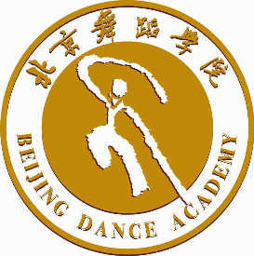

**伦敦大学金史密斯舞蹈与表演孔子学院**



